# LAB#08

**Dynamic Host Configuration Protocol**

Enabling DHCP server in Multi Vlan & Enabling DHCP server in same network.

## Theory:

**Dynamic Host Configuration Protocol (DHCP)**

Dynamic Host Configuration Protocol (DHCP) is a client/server protocol that automatically provides an Internet Protocol (IP) host with its IP address and other related configuration information such as the subnet mask and default gateway.

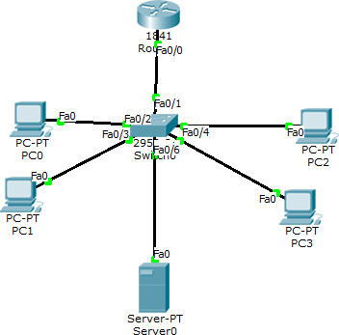

## Static IP Addressing:

With static IP addressing, addresses are assigned manually, and have to be provisioned carefully so that each device has its own address—with no overlap. When you connect a new device, you would have to select the "manual" configuration option and enter in the IP address, the subnet mask, the default gateway.

## IP helper-address:

ip helper-address command can take a broadcast and turn it into a unicast.

As we know, while routers accept and generate broadcasts, they do not forward them. This can be quite a problem when a broadcast needs to get to a device. If the PC attempts to locate a DNS server with a broadcast, the broadcast will be stopped by the router and will never get to the DNS server. By configuring the ip helper-address command on the router, UDP broadcasts such as this

will be translated into a unicast by the router, making the communication possible. The command should be configured on the interface that will be receiving the broadcasts.

## Procedures:

Step#1.(Coding on Switch)

Create three vlans and also configure router and switch.

Step#2(Server)

Assign static ip to server.

Step#3(Server)

Assign ip to dhcp server

Step#4(configure Router) Configure router.(its for one vlan)

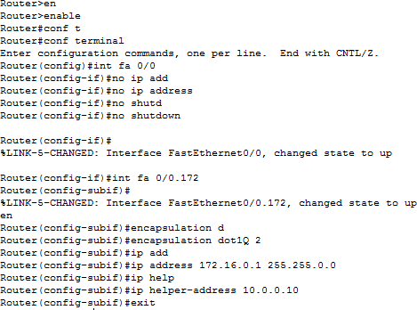

## Exercises:

**Q1.** Which one is better among static & dynamic ip addressing?

Typically, static IP addresses are best for businesses, which host their own websites and internet services. Static IP addresses also work well when you have remote workers logging into work via a VPN.

Dynamic IP addresses are usually fine for most consumers. They are cheaper and typically pose a bit less of a security risk.

**Q2.** Define benefits of DHCP.

DHCP provides the following benefits.

1. Reliable IP address configuration. DHCP minimizes configuration errors caused by manual IP address configuration, such as typographical errors, or address conflicts caused by the assignment of an IP address to more than one computer at the same time.
2. Reduced network administration.

**Q3**. What is an IP Helper address feature and why is it required in a DHCP environment**.**

The helper address feature tells the router to “listen” for DHCP packets, and then the router repackages the packet into a unicast packet and sends it to the DHCP server on the other network and waits for the reply.

* 1. What information a DHCP server provide to a host?.

A DHCP Server is a network server that automatically provides and assigns IP addresses, default gateways and other network parameters to client devices. It relies on the standard protocol known as Dynamic Host Configuration Protocol or DHCP to respond to broadcast queries by clients.

* 1. Difference between static & dynamic addressing.

Static ip address does not change any time, it means if a static ip address is provided then it can't be changed or modified. While dynamic ip address change any time.

* 1. What is purpose of DHCP server?

DHCP (Dynamic Host Configuration Protocol) is a network management protocol used to dynamically assign an Internet Protocol ([IP](https://searchunifiedcommunications.techtarget.com/definition/Internet-Protocol)) address to any device, or [node](https://searchnetworking.techtarget.com/definition/node), on a network so they can communicate using IP. DHCP automates and centrally manages these configurations rather than requiring network administrators to manually assign IP addresses to all network devices. DHCP can be implemented on small local networks, as well as large enterprise network

* 1. Which two tasks does the Dynamic Host Configuration Protocol perform? (Choose two)

1. Set the IP gateway to be used by the network.
2. Perform host discovery used DHCP DISCOVER message.
3. Configure IP address parameters from DHCP server to a host.
4. Provide an easy management of layer 3 devices.
5. Monitor IP performance using the DHCP server.
6. Assign and renew IP address from the default pool?

**C and F**

* 1. netsh dhcp server scope 192.168.1.0 add exclude range 192.168.1.1 192.168.1.25

1. Server core, create DHCP reservations
2. Server core, create DHCP exclusions
3. Server core start the DHCP service.
4. Server core, create DHCP scope.

**B**

**Q.9** 10.0.0.0 255.0.0.0 (Assignable IP range - 10.0.0.1-10.255.255.254) is:

1. Class C
2. Class D
3. Class A
4. Class B
   1. A ProCurve 3500yl switch is connected to port 1 of a ProCurve NAC 800 and a DHCP server is connected to port 2. The DHCP server IP address is 10.1.10.10/24. The NAC 800 IP address is 10.1.10.20/24. The IP address 10.1.24.1/24 is assigned to VLAN 24 on the switch. Which additional configuration settings would be appropriate for supporting a 10.1.24.0/24 non- quarantine subnet and a 10.1.25.0/24 quarantine subnet? (Select two.)
5. on the switch, a multinetted IP address of 10.1.25.1/24 assigned to VLAN 24
6. on the NAC 800, the IP address of the DHCP server specified as 10.1.10.10/24
7. on the NAC 800, IP addresses 10.1.24.51 through 10.1.24.100 defined as exceptions
8. on the switch, the IP helper addresses 10.1.10.10 and 10.1.10.20 defined for VLAN 24
9. on the DHCP server, one scope for 10.1.24.0/24 and a second scope for 10.1.25.0/24?

**A and D**

* 1. Configure the following network (Assigning DHCP server in same network).

